Open in app or online

Arctic Convoy JW53 battered in gales

25th February 1943: The seas are so heavy that many ships lose deck cargo and suffer structural damage before being attacked by German bombers
FEB 25

SAVE |  | ▷ LISTEN

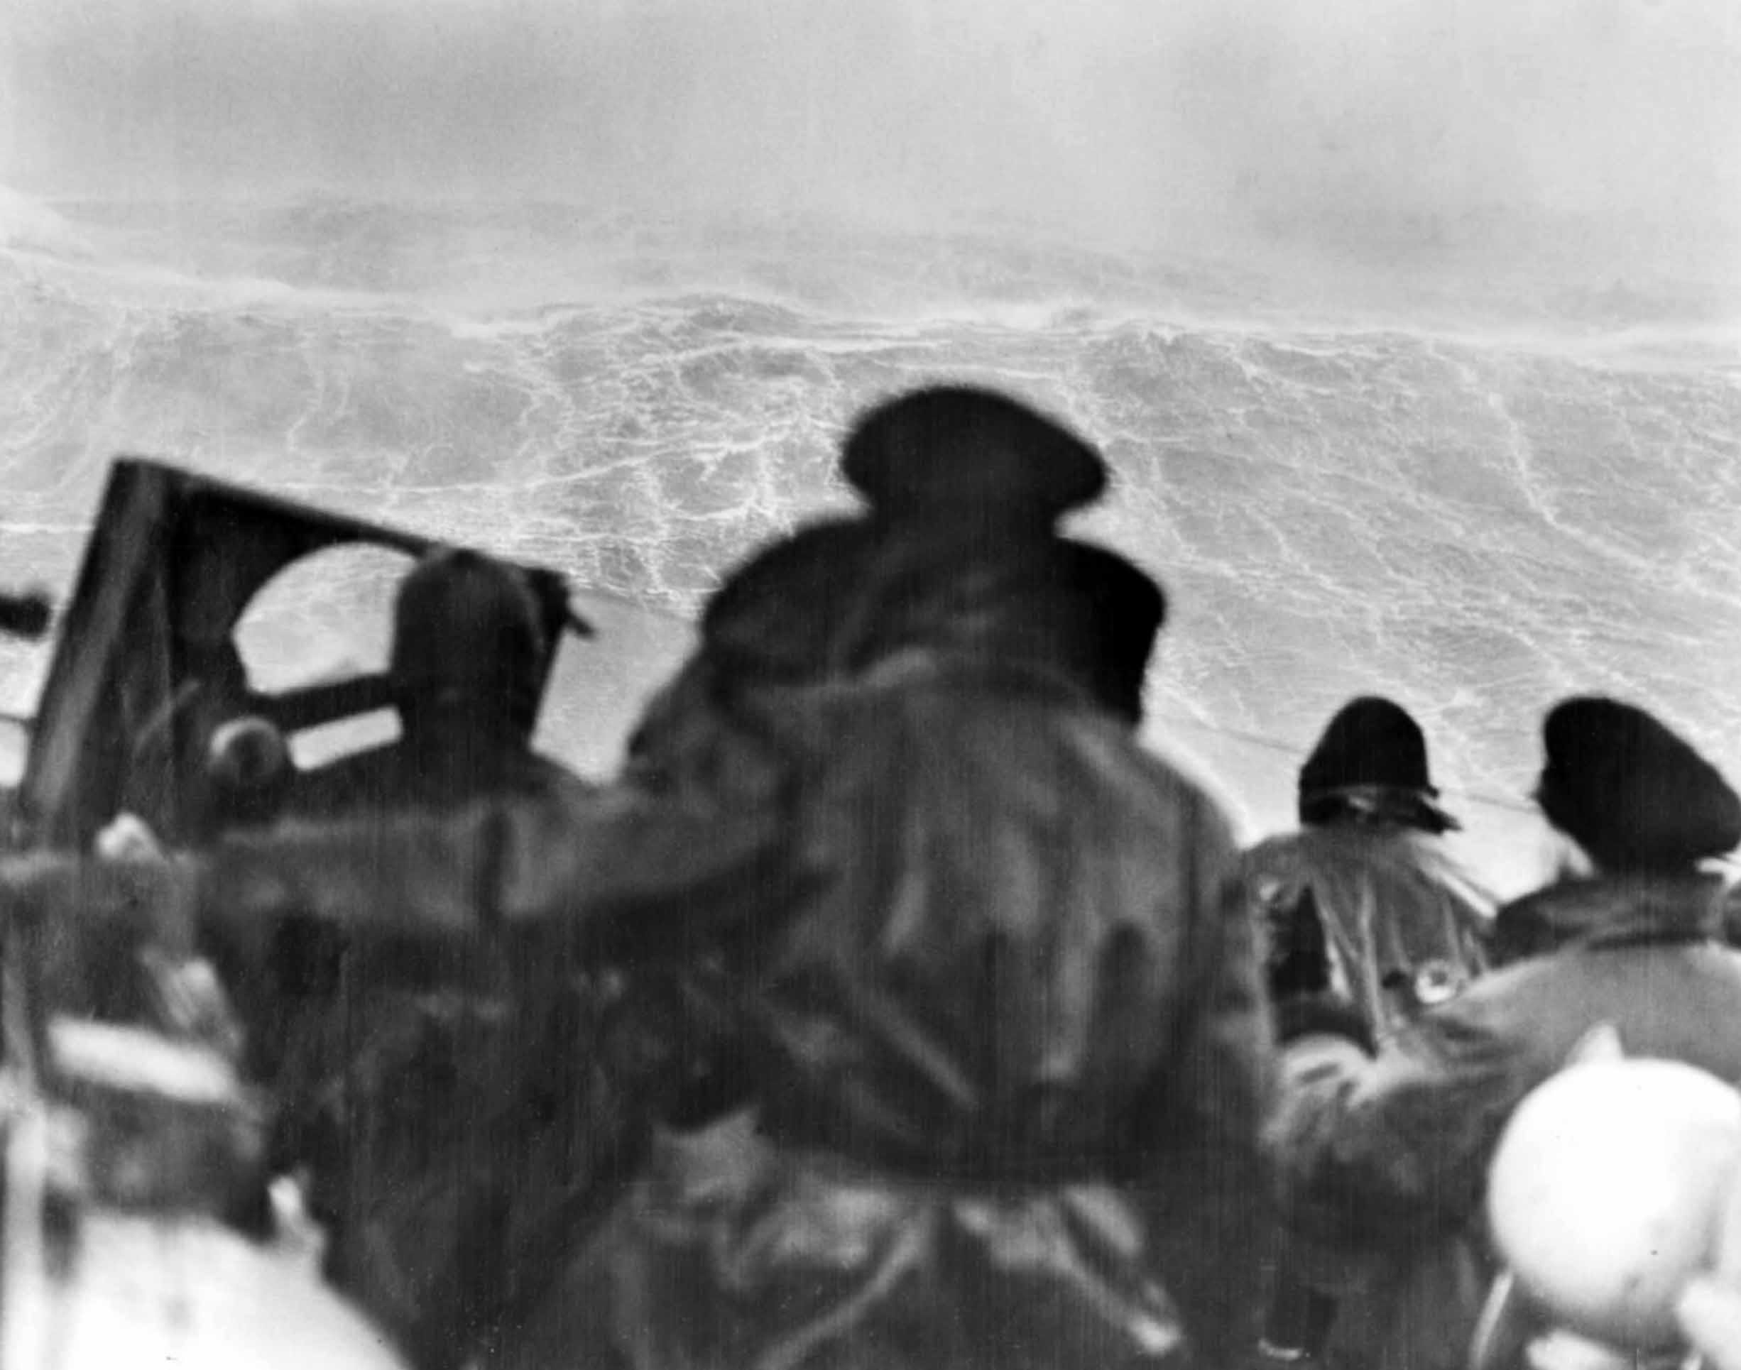
The view from the bridge of HMS Sheffield as Convoy JW53 is battered by an arctic storm.
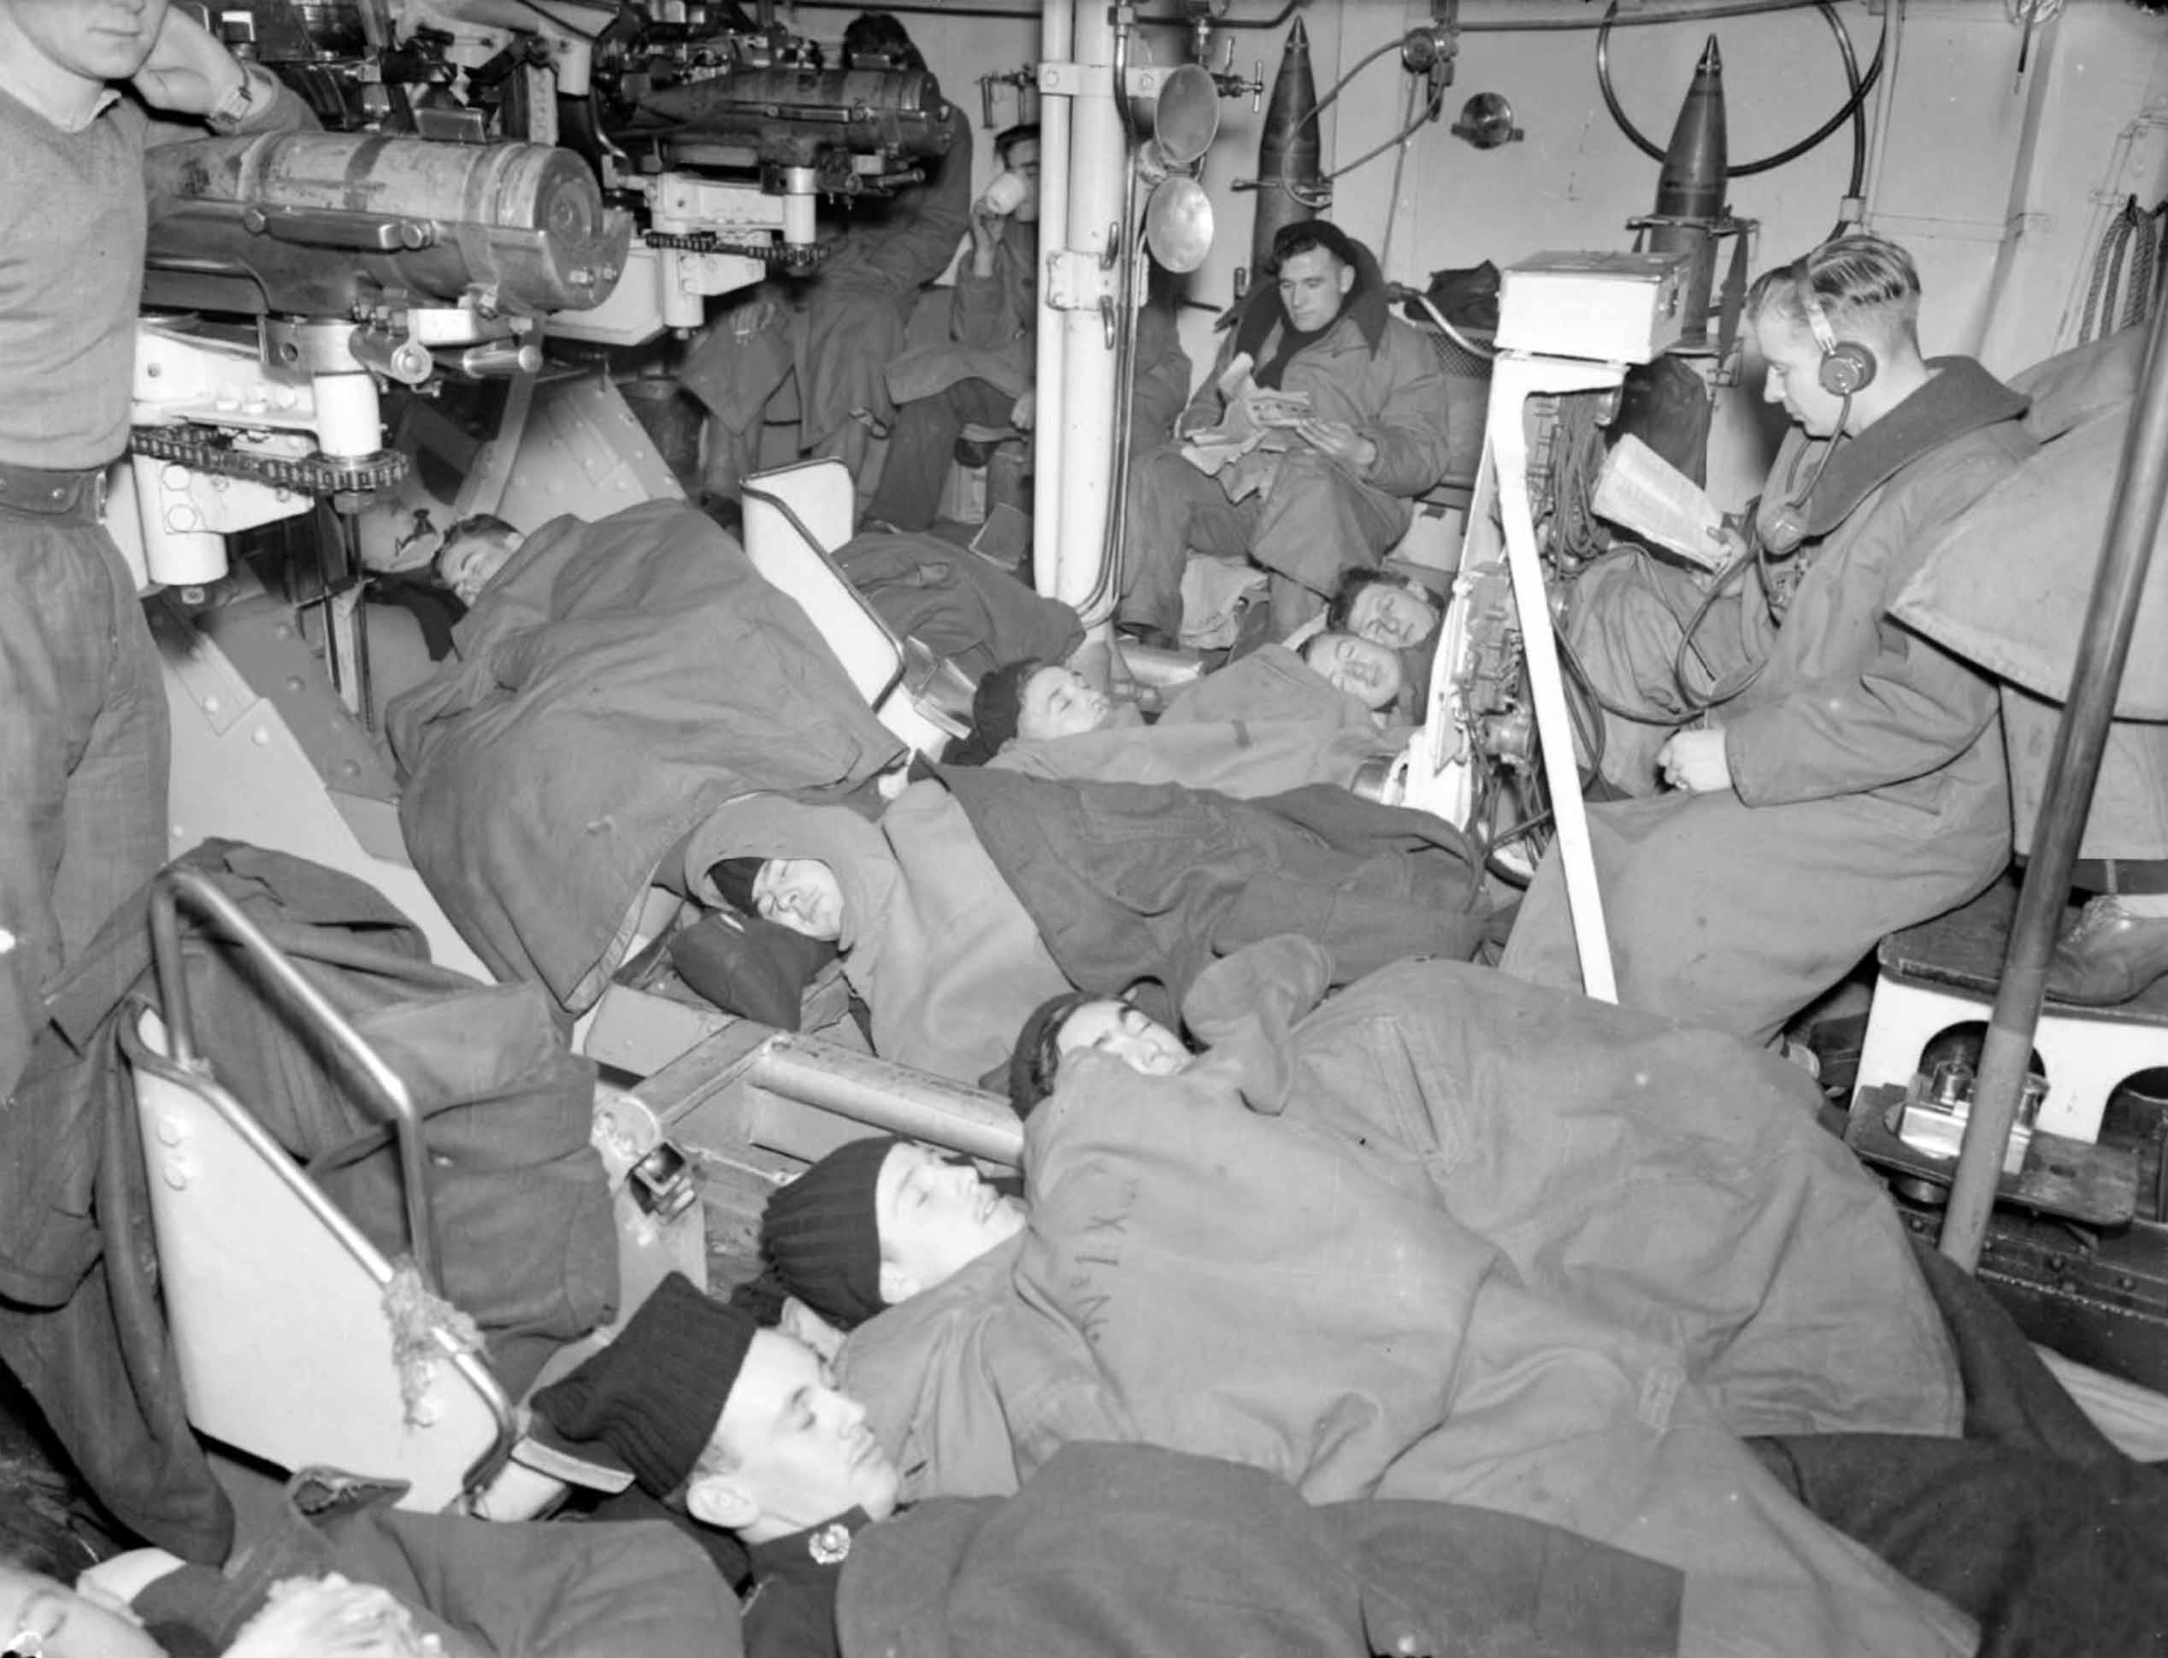
Inside one of the gunhouses for the triple mounted 6 inch gun aboard HMS SHEFFIELD on an earlier convoy. Royal Navy sailors and Royal Marines sleep on the floor of the gunhouse. Others stand or sit whilst reading. 6-inch armour-piercing shells sit in the gun cradles ready for immediate action
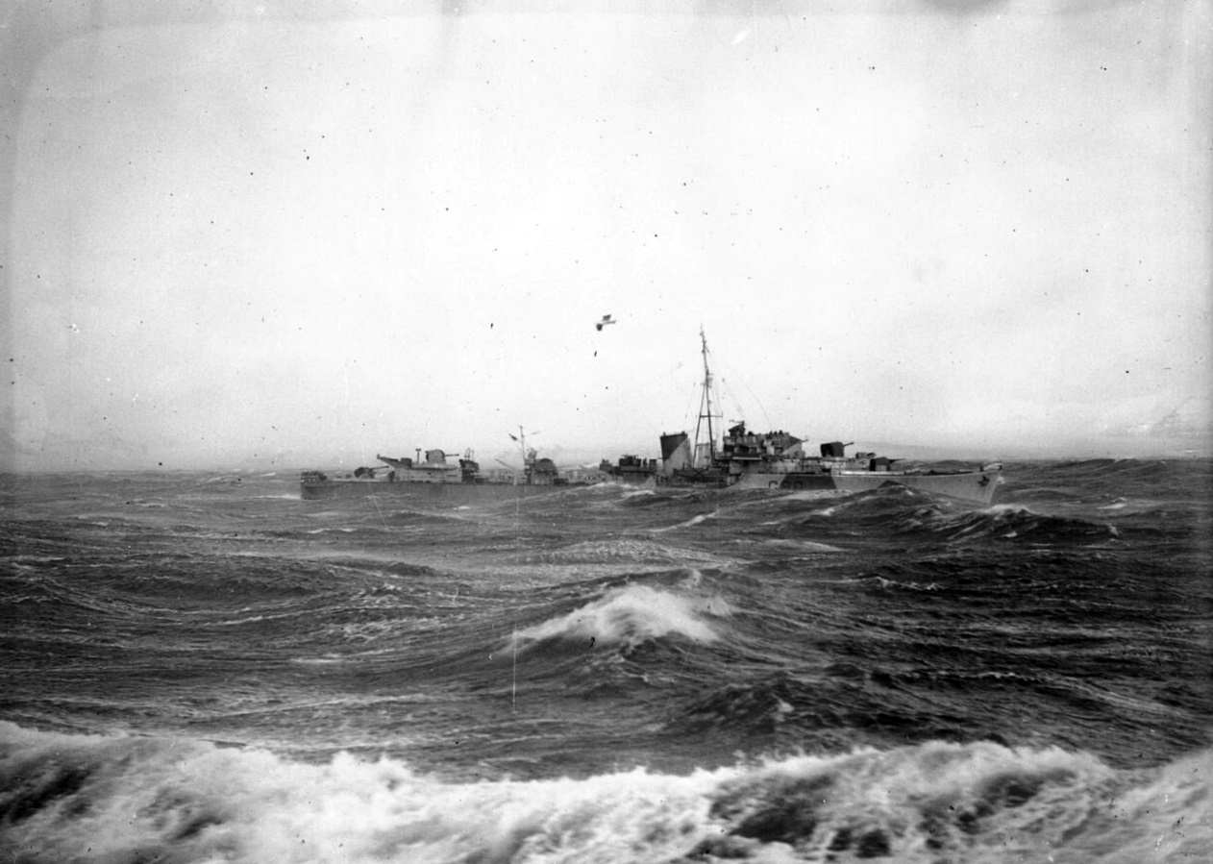
HMS OPPORTUNE, an escorting destroyer, in dazzle paint, seen during rough seas on a Russian convoy patrol. Image taken from aboard HMS INGLEFIELD.
Munitions and supplies from the United States, carried by British and American merchant ships to the Soviet Union, were a vital part of sustaining the Red Army. The Royal Navy took the largest part of the escort work, taking the merchant ships through the icy northern seas around the North Cape. Earlier convoys had come under sustained attack from German torpedo planes and bombers, and there was always the risk of German capital ships making an appearance.
Some men on Convoy JW53 would therefore have welcomed the bad weather that they encountered, which shielded them from the enemy. Others might have felt that the treacherous seas were an enemy in themselves.
The storm that hit Convoy JW 53 was exceptional, the mountainous seas bad enough to cause structural damage to large ships. Many ships had deck cargo washed away. Six merchant ships and HMS Sheffield had to turn back and take shelter in Iceland after suffering serious storm damage.
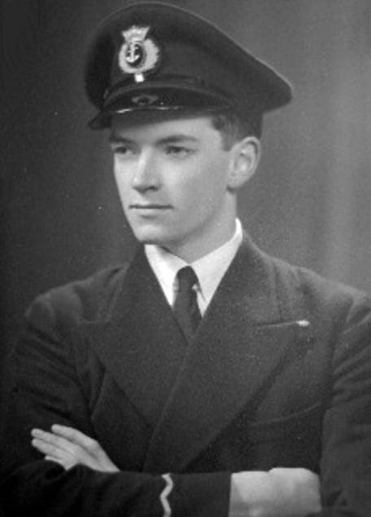
David B Craig, the radio officer on the SS Dover Hill, pictured on return from Russia, in December 1943. He celebrated his eighteenth birthday during the trip. Craig, with 14 other sailors, received the King’s Commendation for Brave Conduct, for participating in the disposal of an unexploded bomb that buried itself in the coal bunker of the Dover Hill while at anchor in the Misukovo Anchorage.
David Craig¹ was on the Dover Hill
heavily loaded with Fighter Aircraft, tanks, guns lorries and a large tonnage of shells and high explosives. Our deck cargo was made up of lorries in cases, Matilda tanks and drums of lubricating oil covered with a layer of sandbags, presumably to protect them from tracer bullets. Needless to say we were not very happy about this last item.
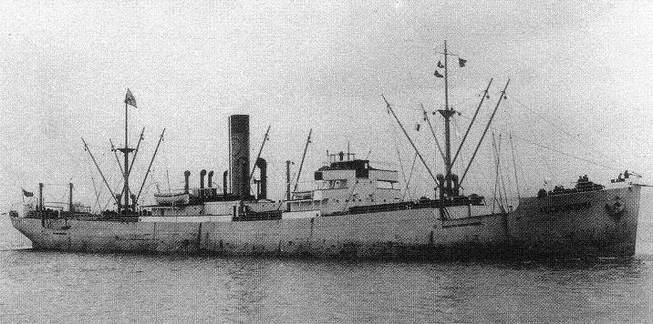
The SS Dover Hill survived the Arctic convoys, including being hit by a bomb while at anchor. She was scuttled as a ‘Corn Cob’ block ship in the Sword landing area, Normandy, June 9th 1944.
On February 15th twenty eight Merchant ships set out in a gale for North Russia in the heavily defended Convoy No. JW 53. The escort was made up of three cruisers, one anti-aircraft cruiser, one escort carrier, sixteen destroyers, two minesweepers, three corvettes and two trawlers which was a very good escort and as the daylight hours were getting longer, trouble was obviously expected.
Due to having to maintain absolute wireless silence the Radio Officers stood their watches on the bridge with the Navigation Officers on duty.
As we sailed North the gale developed into a hurricane and ships began to get damaged. Six of the merchant ships were damaged and had to return to Iceland.
On our ship the deck cargo began to break adrift and we were not sorry to see the oil drums going over the side but when the lorries in wooden cases were smashed up and eventually went overboard things were not so good. But we managed to save the tanks and kept on battering our way northwards.
I remember trying to use an Aldis lamp from our bridge to signal to a Corvette and found it very difficult since one minute she would be in sight, then she would go down the trough of the wave and all I could see would be her top masts; then up she would come and our ship would go down and all that would be seen was water, but eventually we got the message through.
At one stage the convoy was well scattered but as the weather moderated the Navy rounded us all up and got us into some semblance of order once again.
The loss of our escort carrier meant that we had no air cover and, as expected, a few days later a German spotter plane arrived which flew round the convoy all the daylight hours to keep an eye on us. The next day we had a heavy attack by JU 88 bombers in which our ship was damaged and our gunlayer was wounded by bomb splinters but we still kept plodding on towards North Russia.
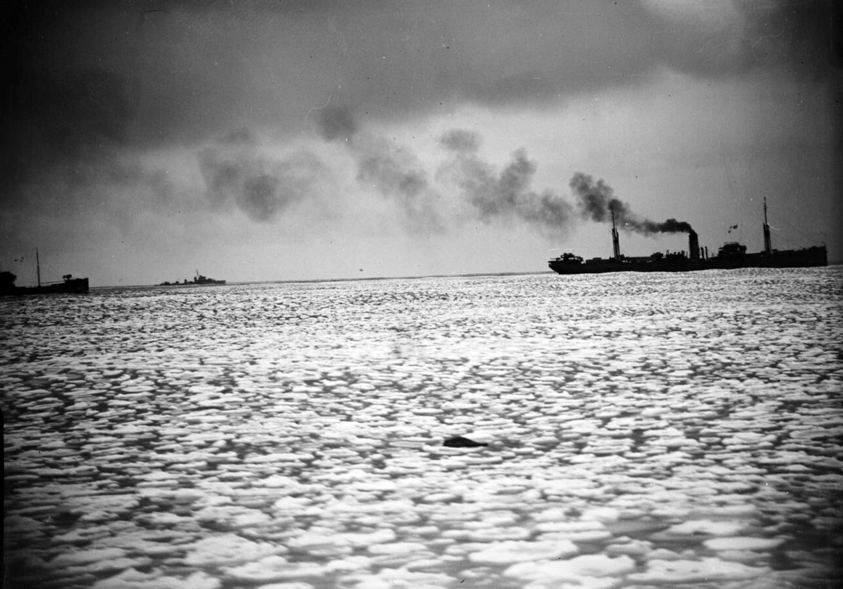
Merchant ships of convoy JW53 passing through pack ice during the voyage. An escort destroyer can be seen in the background. View from the Dido class cruiser HMS SCYLLA.
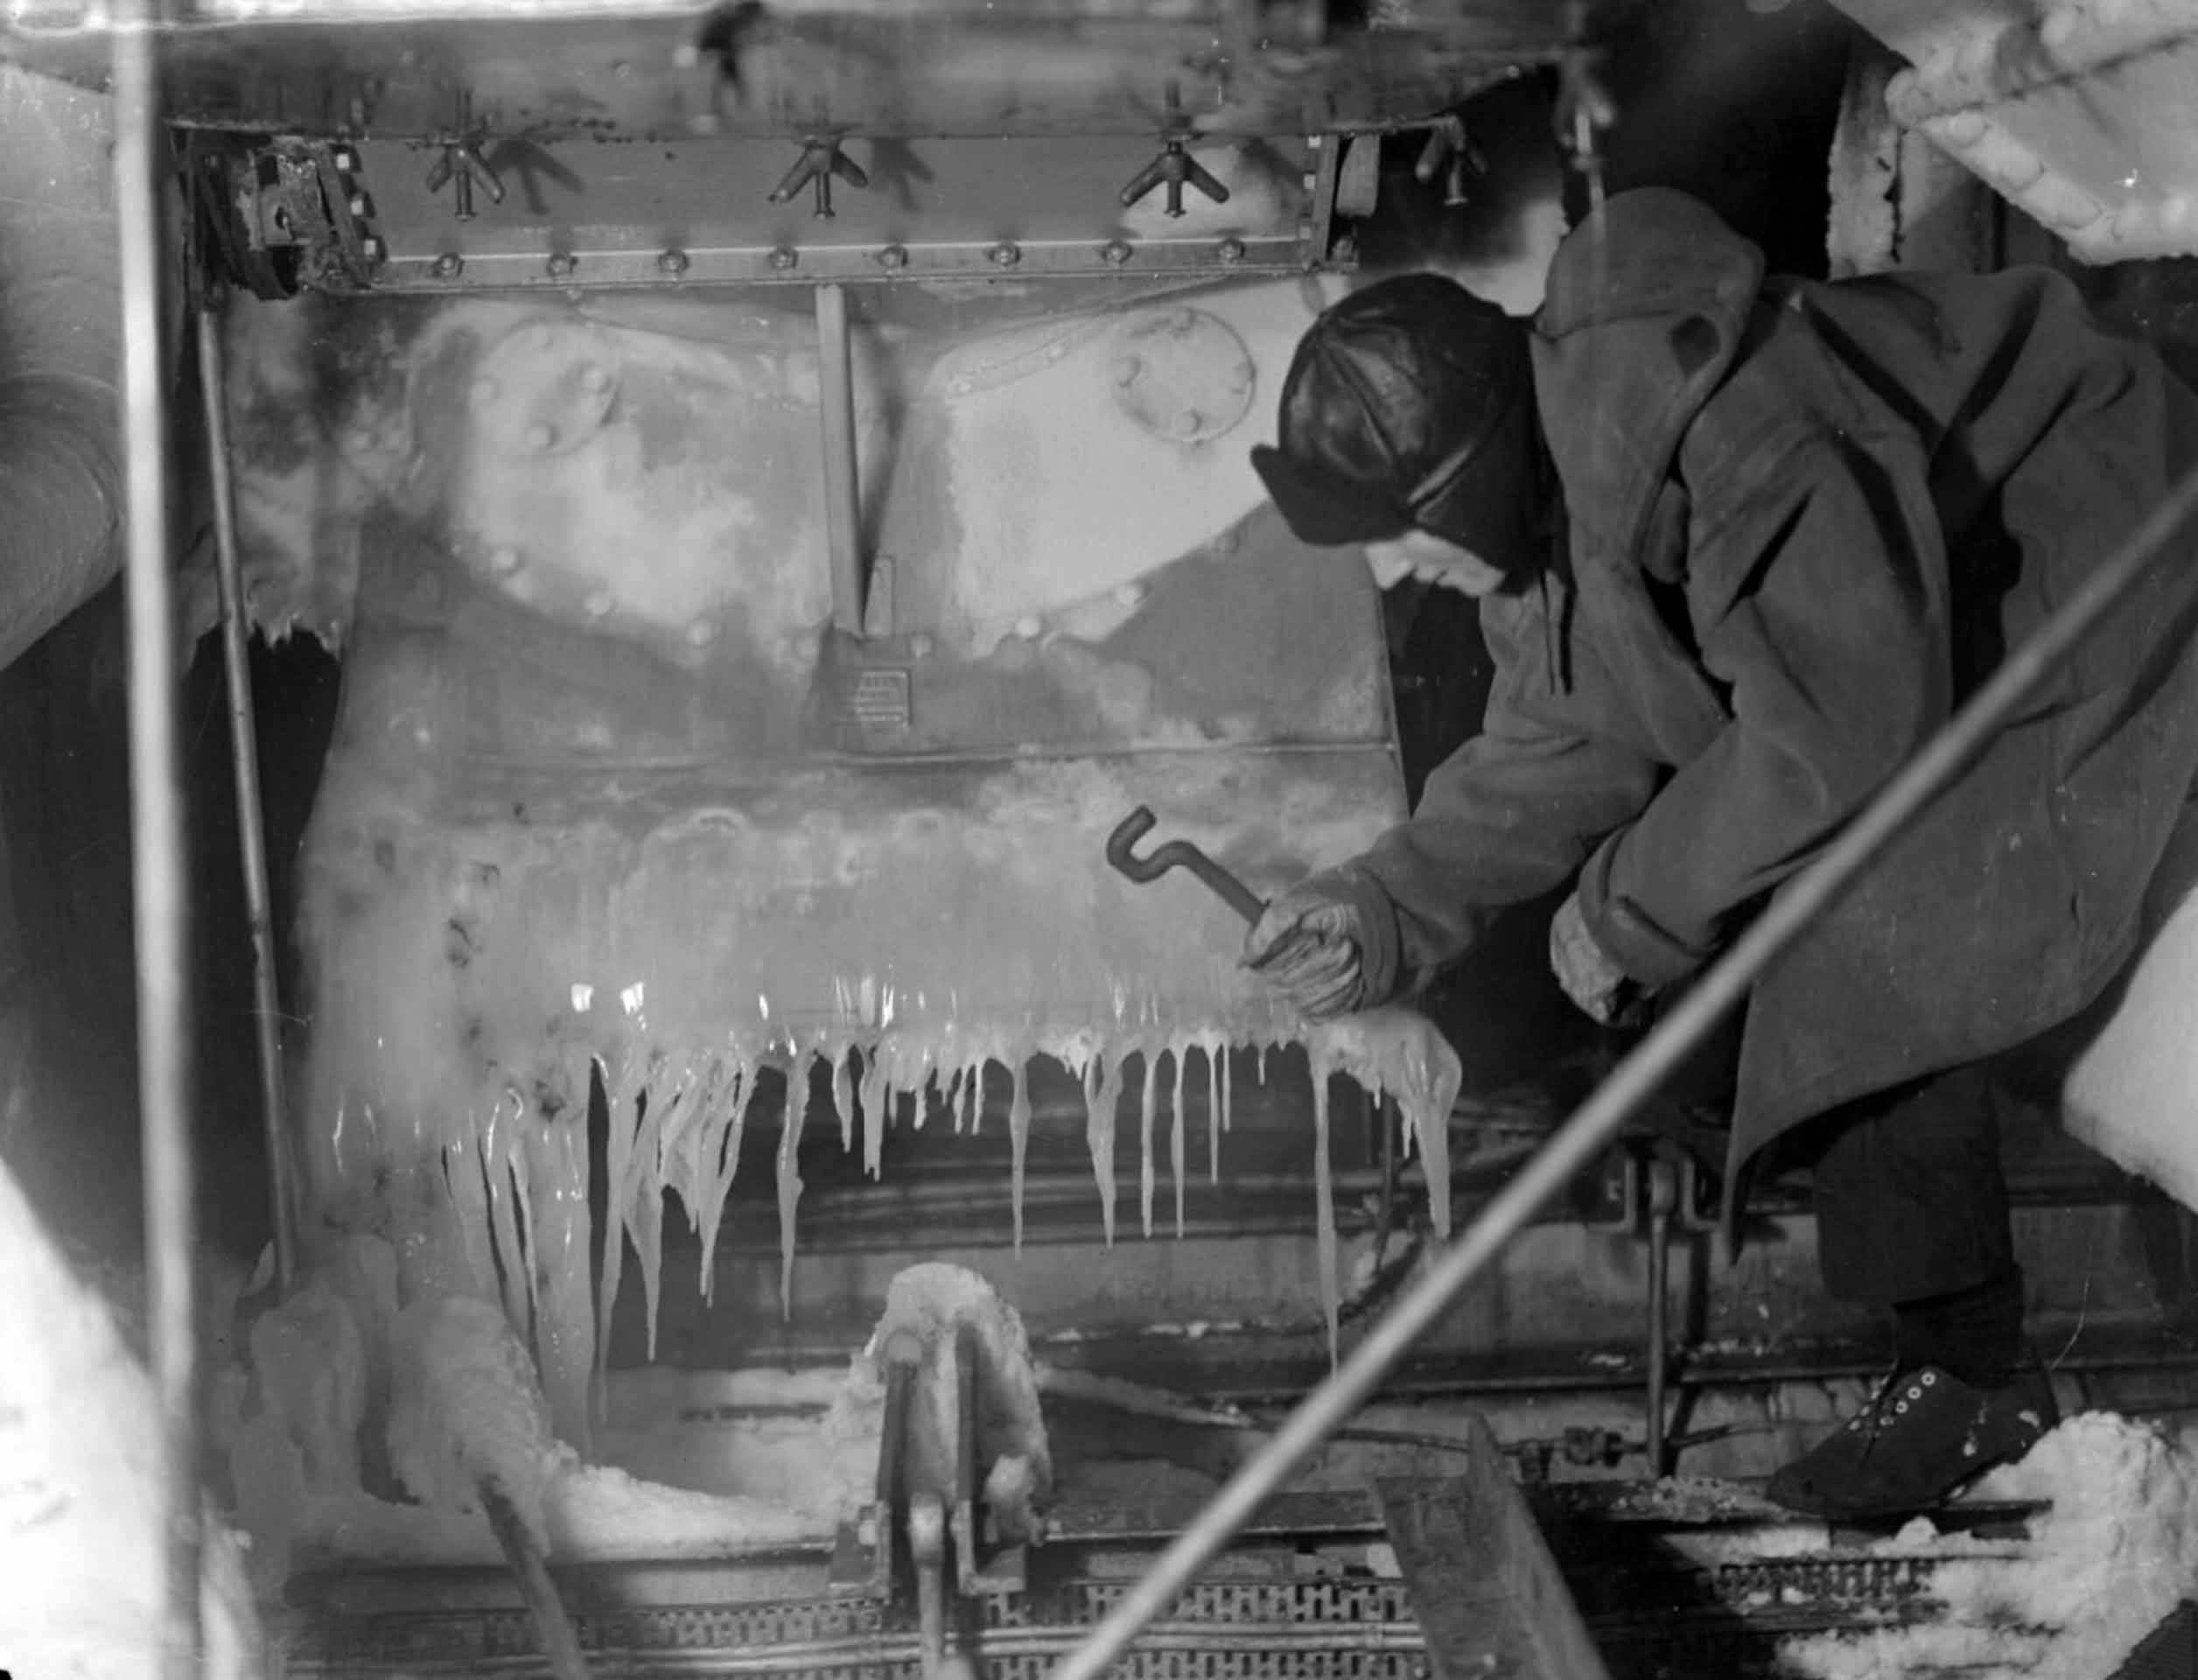
HMS Sheffield. Freeing chains, wires and bollards from ice on the fo`c'sle.
At this part of the voyage we were steaming through pancake ice floes which protected us from the U-boats which could not operate in these conditions. The blizzards when they came were always welcome as they hid us from the enemy.
Two days later, on 27th February, we arrived at the entrance to the Kola Inlet which is a long fiord with hills on either side and the town of Murmansk situated near the top.
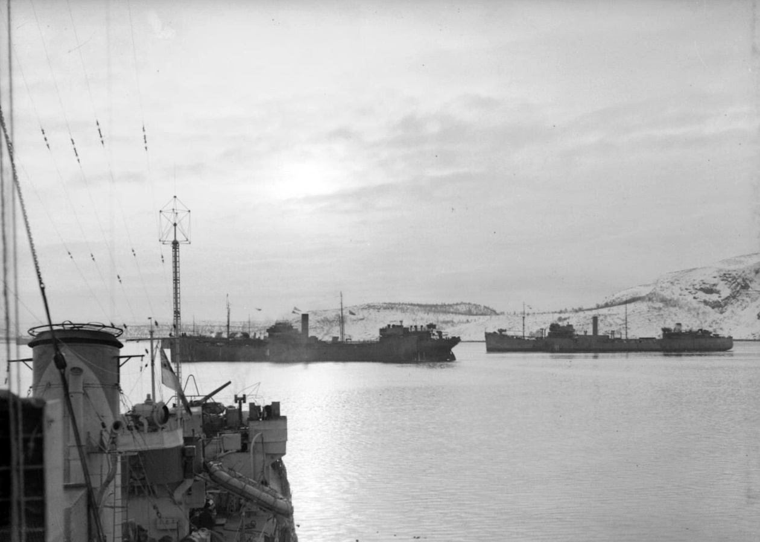
Two merchant ships at anchor in Kola Inlet, north Russia. Part of HMS INGLEFIELD, aboard which this photograph was taken, is in the foreground.
We had not lost any ships to the enemy and I must pay tribute to the good job done by the Royal Navy and our own D.E.M.S and Maritime Regiment Gunners on the merchant ships. Of the twenty two merchantmen in our convoy, fifteen were bound for Murmansk and the remaining seven went on to the White Sea ports near Archangel.
Little did we know at this time that we would not leave Russia until the end of November. The Navy ocean-going escorts which had taken us to the Inlet would now refuel and set off homeward with the empty ships from the previous convoy.
He was not alone in remaining in Russia until November. Several ships were meant to remain there until a return convoy could be organised, but this did not happen until October - they became known as the ‘Forgotten Convoy’.
Amongst them were several US Merchant Marine² ships and eventually the US Naval Attache in Russia issued members of their crews with certificates. A typical certificate was issued to Third Engineer Philip N. Enegess:
Be it known to all men by these presents: That Philip N. Enegess on board the SS City of Omaha, did suffer eight months confinement in North Russia and did undergo all privations connected therewith, that he did shiver through the Arctic and bask in the rays of the midnight sun, and by virtue of these facts is herewith declared to be a certified member of the Forgotten Convoy.
1
BBC People’s War
2
See US Merchant Marine.

